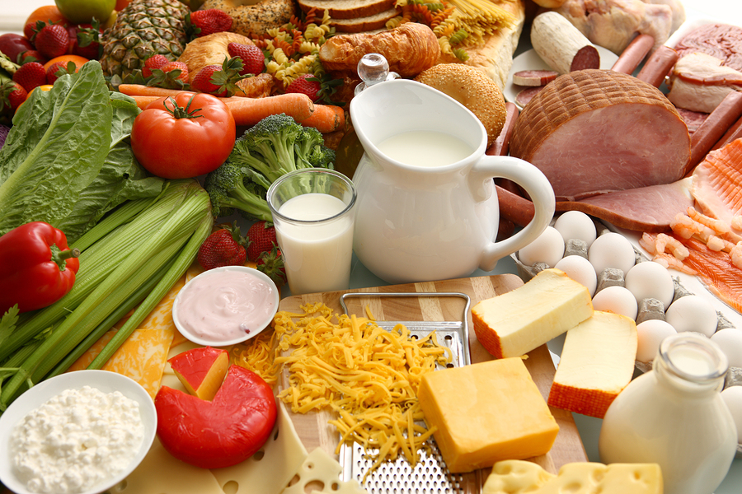

|  |  |  |  |
| --- | --- | --- | --- |
| **DAYS OF WEEK**  **Week 1** | **BREAKFAST** | **LUNCH** | **DINNER** |
| **MONDAY** | A selection of cereals  Freshly made porridge  Orange Juices, Milk, Hot chocolate  Freshly made toast and preserves  COOKED BREAKFAST | Chicken Pie  Or  Beef Lasagna  Potatoes and Vegetables  Cheese Cake | Omelette  Chicken Soup  Selection of sandwiches  Cherry sponge |
| **TUESDAY** | A selection of cereals  Freshly made porridge  Orange Juices, Milk, Hot chocolate  Freshly made toast and preserves  COOKED BREAKFAST | Meat Loaf  Or  Salmon with parsley sauce  Potatoes and vegetables  Cherry crumble and Custard | Cauliflower Cheese  Tomato Soup  Selection of sandwiches  Sago with Jam |
| **WEDNESDAY** | A selection of cereals  Freshly made porridge  Orange Juices, Milk, Hot chocolate  Freshly made toast and preserves  COOKED BREAKFAST | Roast Lamb  Or  Corned Beef Hash  Potatoes and Vegetables  Coconut Cake | Potato Pie  Mushroom Soup  Selection of sandwiches  Orange Sponge |
| **THURSDAY** | A selection of cereals  Freshly made porridge  Orange Juices, Milk, Hot chocolate  Freshly made toast and preserves  COOKED BREAKFAST | Shepherd’s Pie  Or  Macaroni cheese  Potatoes and Vegetables  Quinn pudding | Quiche  Vegetable Soup  Selection of sandwiches  Lemon pudding |
| **FRIDAY** | A selection of cereals  Freshly made porridge  Orange Juices, Milk, Hot chocolate  Freshly made toast and preserves  COOKED BREAKFAST | Fish and Chips  OR  Sausage Casserole  Potatoes and Vegetables  Tiramisu | Corned Beef Hash  Minestrone Soup  Selection of sandwiches  Apple Tart |
| **SATURDAY** | A selection of cereals  Freshly made porridge  Orange Juices, Milk, Hot chocolate  Freshly made toast and preserves  COOKED BREAKFAST | Beef Stroganoff  Or  Cheese and tomato quiche Potatoes and Vegetables  Lemon Cake | Beans on Toast  Leek and Potatoes Soup  Selection of sandwiches  Pineapple upside down cake |
| **SUNDAY** | A selection of cereals  Freshly made porridge  Orange Juices, Milk, Hot chocolate  Freshly made toast and preserves  COOKED BREAKFAST | Roast Beef + Yorkshire Pudding  Or  Ham Pie  Potatoes and Vegetables  Victoria Cake | Sausage Roll  Kidney Bean Soup  Selection of sandwiches  Cherry Sponge |



|  |  |  |  |
| --- | --- | --- | --- |
| **DAYS OF WEEK**  **Week 2** | **BREAKFAST** | **LUNCH** | **DINNER** |
| **MONDAY** | A selection of cereals  Freshly made porridge  Orange Juices, Milk, Hot chocolate  Freshly made toast and preserves  COOKED BREAKFAST | Cottage Pie  Or  Omelette  Potatoes and Vegetables  Bread and butter pudding | Tuna Pasta  Oxtail Squash  Selection of sandwiches  Lemon Meringue Pie |
| **TUESDAY** | A selection of cereals  Freshly made porridge  Orange Juices, Milk, Hot chocolate  Freshly made toast and preserves  COOKED BREAKFAST | Roast Chicken  Or  Fish Fingers  Potatoes and vegetables  Coconut Sponge and Custard | Broccoli and Cheese Pie  Onion Soup  Selection of sandwiches  Victoria Sponge Cake |
| **WEDNESDAY** | A selection of cereals  Freshly made porridge  Orange Juices, Milk, Hot chocolate  Freshly made toast and preserves  COOKED BREAKFAST | Beef Meatballs  Or  Sausage and Mash  Potatoes and Vegetables  Profiteroles | Corned Beef Hash  Carrot Soup  Selection of sandwiches  Mousse |
| **THURSDAY** | A selection of cereals  Freshly made porridge  Orange Juices, Milk, Hot chocolate  Freshly made toast and preserves  COOKED BREAKFAST | Lamb Stew  Or  Tuna Pasta  Potatoes and Vegetables  Trifle | Potato and Leeks Pie  Mix Veg Pie  Minestrone Soup  Selection of sandwiches  Eggs Custard |
| **FRIDAY** | A selection of cereals  Freshly made porridge  Orange Juices, Milk, Hot chocolate  Freshly made toast and preserves  COOKED BREAKFAST | Fish and Chips  OR  Ham and Egg Pie  Potatoes and Vegetables  Apple Crumble and Custard | Pork Pie  Cauliflower Soup  Selection of sandwiches  Peach Crumble |
| **SATURDAY** | A selection of cereals  Freshly made porridge  Orange Juices, Milk, Hot chocolate  Freshly made toast and preserves  COOKED BREAKFAST | Beef and Mushroom Pie  Or  Shepherd Pie  Potatoes and Vegetables  Lemon and Coconut Sponge and Custard | Bubble Squeak  Mixed Vegetable Soup  Selection of sandwiches  Chocolate Sponge |
| **SUNDAY** | A selection of cereals  Freshly made porridge  Orange Juices, Milk, Hot chocolate  Freshly made toast and preserves  COOKED BREAKFAST | Roast Pork and Apple Sauce  Or  Fish Pie  Potatoes and Vegetables  Sultana Sponge | Parsnip Soup  Selection of sandwiches  Bread and Butter Pudding |



|  |  |  |  |
| --- | --- | --- | --- |
| **DAYS OF WEEK**  **Week 3** | **BREAKFAST** | **LUNCH** | **DINNER** |
| **MONDAY** | A selection of cereals  Freshly made porridge  Orange Juices, Milk, Hot chocolate  Freshly made toast and preserves  COOKED BREAKFAST | Chicken Rapped with bacon  Or  Corned Beef Hash  Potatoes and Vegetables  Chocolate Sponge | Jacket Potato with Cheese  Chicken Soup  Selection of sandwiches  Cherry Pie |
| **TUESDAY** | A selection of cereals  Freshly made porridge  Orange Juices, Milk, Hot chocolate  Freshly made toast and preserves  COOKED BREAKFAST | Roast Pork  Or  Fish Cakes  Potatoes and vegetables  New York Cheese Cake | Cornish Pastry  Mushroom Soup  Selection of sandwiches  Sago with Jam |
| **WEDNESDAY** | A selection of cereals  Freshly made porridge  Orange Juices, Milk, Hot chocolate  Freshly made toast and preserves  COOKED BREAKFAST | Meatloaf  Or  Macaroni Cheese  Potatoes and Vegetables  Rhubarb Crumble | Leeks Omelette  Tomato Soup  Selection of sandwiches  Treacle Tart with Custard |
| **THURSDAY** | A selection of cereals  Freshly made porridge  Orange Juices, Milk, Hot chocolate  Freshly made toast and preserves  COOKED BREAKFAST | Turkey Stroganoff  Or  Scampi  Potatoes and Vegetables  Rice Pudding | Cumberland Pie  Vegetable Soup  Selection of sandwiches  Lemon pudding |
| **FRIDAY** | A selection of cereals  Freshly made porridge  Orange Juices, Milk, Hot chocolate  Freshly made toast and preserves  COOKED BREAKFAST | Fish and Chips  Or  Egg Pie  Potatoes and Vegetables  Apple Pie | Bean and Toast  Minestrone Soup  Homemade Bread with Butter  Selection of sandwiches  Apple Tart |
| **SATURDAY** | A selection of cereals  Freshly made porridge  Orange Juices, Milk, Hot chocolate  Freshly made toast and preserves  COOKED BREAKFAST | Chicken and Mushroom Pie  Or  Ham Pie  Potatoes and Vegetables  Sticky Toffee Pudding | Eggs Pie  Sweet Potato and Carrot Soup  Selection of sandwiches  Pineapple upside down cake |
| **SUNDAY** | A selection of cereals  Freshly made porridge  Orange Juices, Milk, Hot chocolate  Freshly made toast and preserves  COOKED BREAKFAST | Roast Turkey  Or  Beef Lasagne  Potatoes and Vegetables  Jam and Coconut Sponge | Fish Pie  Kidney Bean Soup  Selection of sandwiches  Cherry Sponge |



|  |  |  |  |
| --- | --- | --- | --- |
| **DAYS OF WEEK**  **Week 4** | **BREAKFAST** | **LUNCH** | **DINNER** |
| **MONDAY** | A selection of cereals  Freshly made porridge  Orange Juices, Milk, Hot chocolate  Freshly made toast and preserves  COOKED BREAKFAST | Chicken Stew  Or  Salmon and Cod Fish Pie  Potatoes and Vegetables  Chocolate Sponge and Custard | Potato Ham Pie  Tomato Soup  Selection of sandwiches  Orange Posset |
| **TUESDAY** | A selection of cereals  Freshly made porridge  Orange Juices, Milk, Hot chocolate  Freshly made toast and preserves  COOKED BREAKFAST | Gammon with Parsley Sauce  Or  Spaghetti Bolognaise  Potatoes and vegetables  Lemon Cake and Custard | Corned Beef Pie  Onion Soup Homemade Bread with Butter  Selection of sandwiches  Victoria Sponge Cake |
| **WEDNESDAY** | A selection of cereals  Freshly made porridge  Orange Juices, Milk, Hot chocolate  Freshly made toast and preserves  COOKED BREAKFAST | Roast Pork  Or  Scampi  Potatoes and Vegetables  Pineapple upside down Cake | Cauliflower Cheese  Bean Soup  Selection of sandwiches  Banana Mouse |
| **THURSDAY** | A selection of cereals  Freshly made porridge  Orange Juices, Milk, Hot chocolate  Freshly made toast and preserves  COOKED BREAKFAST | Lamb Hotpot  Or  Prawns Pasta  Potatoes and Vegetables  Rice Pudding | Cheese and Onion Quiche  Minestrone Soup  Selection of sandwiches  Apple and blackberry Pie |
| **FRIDAY** | A selection of cereals  Freshly made porridge  Orange Juices, Milk, Hot chocolate  Freshly made toast and preserves  COOKED BREAKFAST | Fish and Chips  Or  Egg Ham Pie  Potatoes and Vegetables  Manchester Tart and Custard | Cheese Ravioli  Cauliflower Soup  Selection of sandwiches  Peach Crumble |
| **SATURDAY** | A selection of cereals  Freshly made porridge  Orange Juices, Milk, Hot chocolate  Freshly made toast and preserves  COOKED BREAKFAST | Lamb Cobbler  Or  Chicken Rissoles  Potatoes and Vegetables  Chocolate Sponge | Beans and Toast  Mixed Vegetable Soup  Selection of sandwiches  Chocolate Sponge |
| **SUNDAY** | A selection of cereals  Freshly made porridge  Orange Juices, Milk, Hot chocolate  Freshly made toast and preserves  COOKED BREAKFAST | Roast Lamb and Mint Sauce  Or  Fish Pie  Potatoes and Vegetables  Apple Cake | Cheese and Potato Pie  Carrot Soup  Selection of sandwiches  Sticky Toffee Pudding |